Assignment 2(section 1)

1. Create an empty directory ‘Assignments’ & cd to ‘Assignments’

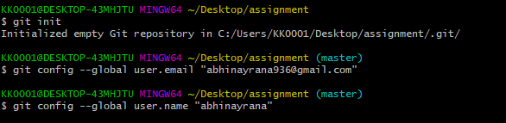

2. Create a file README.txt inside ‘Assignments’ & write few lines about the contents of ‘Assignments’ folder

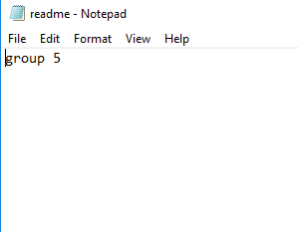

3. Commit readme.txt file

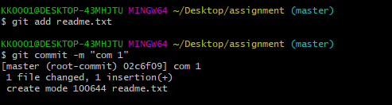

4. Now create a new branch ‘html-assignments’.

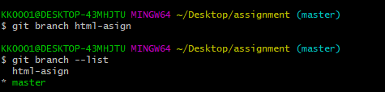

5. switch to html-asign branch and commit the html assignments

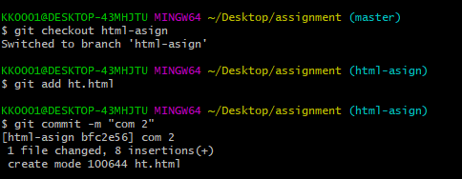

6. Make minor changes into few files belonging to ‘html-assignments’ branch.

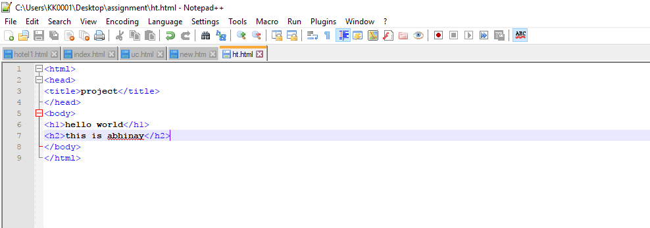

7. Commit those changed files

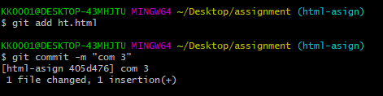

8. Switch to master branch, make minor changes into README.txt file & commit those changes into master.

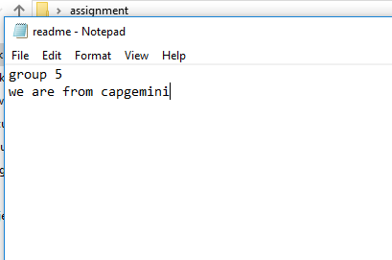

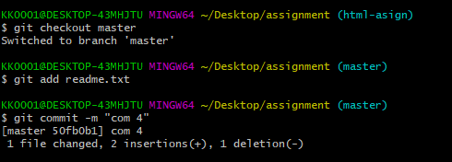

9. Again switch to ‘html-assignments’ branch and commit the changes.

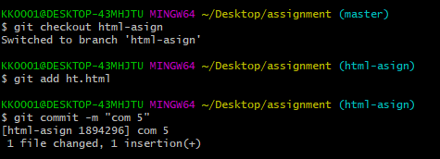

10. Merge ‘html-assignments’ branch into master

C:\Users\KK0001\Desktop\z\sec 1\h13.PNG

11. Finally delete the ‘html-assignments’ branch

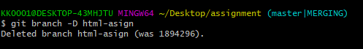

12. Confirm all html assignments are shown in master.